Student’s name | …………………………………………………….…… | Grade | 1
Subject | Computer | Week No. | 6
Lesson Title |  | Unit
Midterm Exam Worksheet

Question A: Match the following

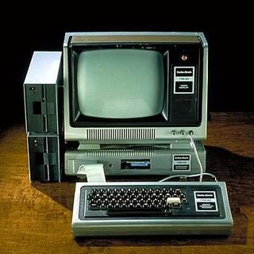 | PERSONAL COMPUTER
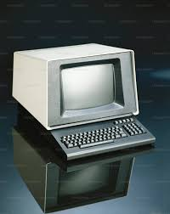 | SUPER COMPUTER
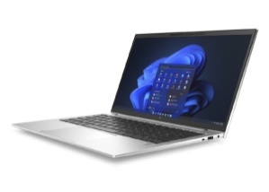 | MICRO COMPUTER
 | MINI COMPUTER
 | LAPTOP

Question B: Match the following

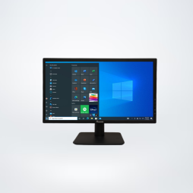 | CPU
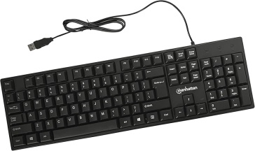 | PRINTER
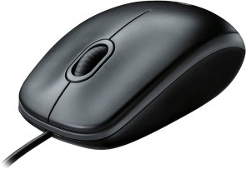 | MONITOR
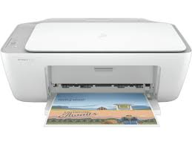 | KEYBOARD
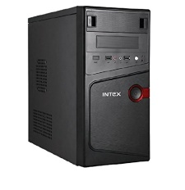 | MOUSE

Question C: Write the correct name of the following devices.

- 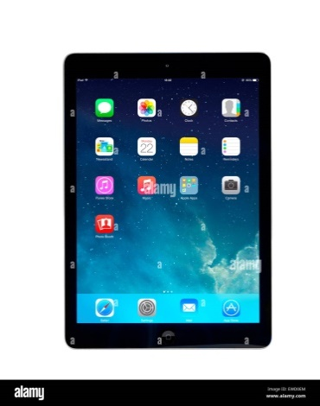 b. 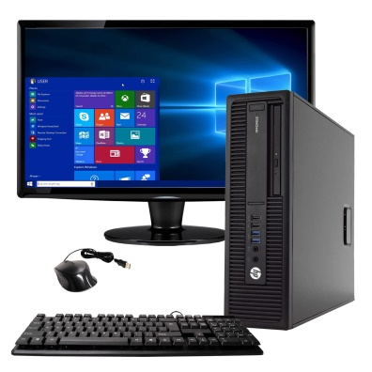
__________________ _________________

c.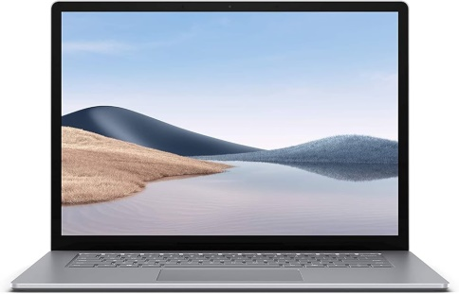 d. 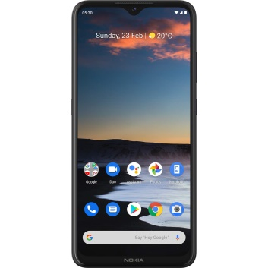

_____________________ __________________

Question D: Color the parts of computer and write their names next to it.

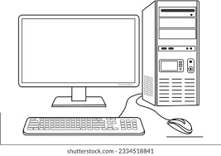

ANSWER KEY
Question A: Match the following

 | PERSONAL COMPUTER
 | SUPER COMPUTER
 | MICRO COMPUTER
 | MINI COMPUTER
 | LAPTOP

Question B: Match the following

 | CPU
 | PRINTER
 | MONITOR
 | KEYBOARD
 | MOUSE

Question C: Write the correct name of the following devices.

-  b. 
Tablet Desktop

c. d. 

Smartphone Laptop

Question D: Color the parts of computer and write their names next to it.


CPU
Monitor

Keyboard
Mouse

